Additional support available from:-
For advice and guidelines on where to seek advice: www.inspirecs.org
Address: Ground Floor, 121 Church Street, St Helens, WA10 IAJ
Tel: 01744 661221
Email: Enquires@inspirecs.org
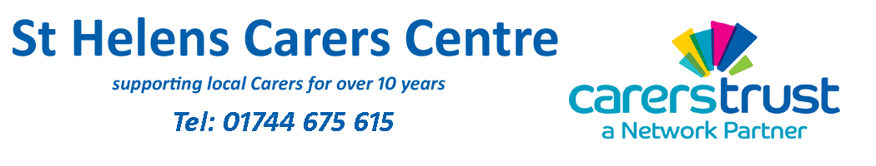
http://www.sthelenscarers.org.uk/youngcarers.html Advice and support for young carers
Tel: 01744 675 615
www.sthelenscarers.org.uk/drugandalcohol.html
Drugs and Alcohol misuse and addiction - St Helens "breaking the cycle" service
Address: Lincoln House, 80 Corporation Street, St Helens, WA10 1UQ.
Tel: 01744 766210.
DRINKLINE - 0800 917 8282
Support Group for parents, families and carers of people with drug misuse issues.
www.footstepsforfamilies.org
YMCA, 2 North Road, St Helens, WA10 2TJ
Tel: 01744 808212.
healthtalk.org or youthhealthtalk.org: advice on all medical issues including Drugs and Alcohol, Eating Disorders, Weight, Sexual Health and Mental Health:
http://www.healthtalk.org/young-peoples-experiences/drugs-and-alcohol/topics
Parentline Plus for parenting advice: www.parentlineplus.org.uk
Tel: 0800 800 2222

Mental Health and Special Educational Needs information
Young Minds www.youngminds.org.uk, for advice on mental health for young people.
https://www.mind.org.uk/media/3120340/autism-guide-web-version.pdf
Positive ways to help a young person accept their autism
http://autism.baydakh.com/index.php/2016/02/08/how-to-accept-your-autism/

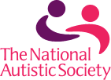
http://www.autism.org.uk/
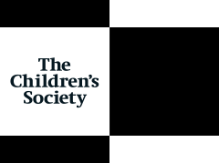
Child Sexual Exploitation information
http://www.childrenssociety.org.uk/old-enough-to-knowbetter?
Guide for parents and carers about self-harming.
https://www.psych.ox.ac.uk/news/new-guide-for-parents-who-are-coping-with-theirchild2019s-self-harm-2018you-are-not-alone2019
http://network.autism.org.uk/knowledge/insight-opinion/interview-professor-tony-attwoodautism-and-mental-health
Organisations that help families
http://www.cafamily.org.uk
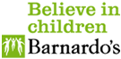
http://www.barnardos.org.uk/what_we_do/our_work/mental_health.htm
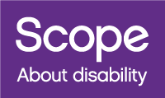
http://www.scope.org.uk/Support/Families/Diagnosis/Learning-difficulties/Mental-health

Alcohol and the Law
It is against the law to sell alcohol to anyone under the age of 18
It is against the law for someone under 18 to buy or try to buy Alcohol
It is against the law for an adult to buy or try to buy alcohol on the behalf of someone under the age of 18. If caught buying alcohol for someone under 18 then you are committing a criminal offence not them and you could face a fine of up to £5000.
It is against the law for someone under 18 to drink alcohol in a licenced premises
Children 16 or 17 and accompanied by an adult, can drink (but not buy) beer, wine or cider with a meal.
It is illegal to give a child under 5 alcohol.
You can be stopped, fined or arrested by police if you’re under 18 and drinking alcohol in public.
If you suspect a premises of selling alcohol or tobacco to a young person you can report them to Trading Standards via Citizens Advice Consumer Helpline on – 0345 4040 506
The consequences of drinking visit – www.eahconsequences.com
: Information about alcohol and the effects on young people www.drinkaware.co.uk
Drinkline Tel: 0300 123 1110 (weekdays 9am–8pm, weekends 11am–4pm)
Alcohol Concern: www.alcoholconcern.org.uk
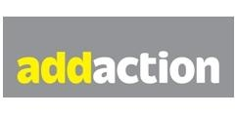
Address: Lincoln House, 80 Corporation Street, St Helen, WA10 1UQ
Tel: 01744 766210
Young People’s Services
Address: Young People's Drug and Alcohol Team, Lord Street Centre, Lord Street, St. Helens, WA10 2SP
Tel: 01744 675 605
Opening Times - Monday - Friday 9am - 5pm (late appointments can be arranged if required)

Cigarettes and the Law
It is an offence for a person 18 or over to buy, or attempt to buy tobacco or cigarette papers,
E-cigarettes and e-liquids on the behalf of someone under the age of 18.
It is illegal to smoke in a car (or other vehicle) with anyone under 18. Both the driver and the smoker could be fined £50. The law applies to every driver in England and Wales, including those aged 17 and those with a provisional driving license. Exempt from the law are e-cigarettes (vaping) and a driver who is 17 years old if they are on their own in the car.
www.nhs.uk/Livewell/smoking/Pages/Teensmokersquit.aspx
Smokefree St Helens is a local service Hub providing support: https://www.sthelens.gov.uk/smokefree
Hub Opening Hours -- Monday, Wednesday, Thursday and Friday: 9am-5pm, Tuesday 9am-12noon, Saturday 10am-2pm
Address: Unit 2, The Hardshaw Centre, Church Street, St Helens, WA10 1EB
Tel: 01744 586247 or text QUIT to 61825
Cannabis and the Law
Cannabis is a Class B drug and is illegal and anyone caught in the possession of cannabis could face a police warning, caution, reprimand, or a fixed penalty, arrest and a possible conviction.
www.talktofrank.com
Tel: 0800 77 6600 Confidential and free (from a landline)
Email: frank@talktofrank.com
Young People's Drug and Alcohol Team (YPDAAT) - St. Helens
http://yaz.sthelens.gov.uk/main-sections/drugs-alcohol/
The Young Peoples Drug & Alcohol Team provides advice and support to young people, aged up to 19 in St Helens.

