Student Photographic Competition 2016-17
Student Activity
It has been decided that following the successful Student Photographic Competition last year we would hold another one this year. Feedback from students, staff and the general public who visited the exhibition at the Cathedral was overwhelmingly positive. The quality of the images and the messages that described the context for the photographs were inspiring to many people and their comments reflected this. It was an activity that really engaged many staff and students.
The Activity
Similar to last year, schools will be invited to submit two entries, one from students in Years 7 to 9, and the other for older students in Years 10 to 11 or 13 if the school/college has a sixth form. There will be prizes for those judged to be in the top three for each category. It is up to schools to determine how they decide what pieces of work are submitted, but this could feasibly take the form of a house/year competition that captures the imagination of a number of students, or could be subject specific e.g. RE, Art or another subject that would like to approach this from their curriculum perspective.
Theme
‘We are valued, we are unique, we have faith, we are a family and we are the future’
Any photograph chosen to represent the school’s ‘entry’ should be accompanied by some descriptive text not exceeding 150 words. Each school should be prepared to submit two entries that could then be displayed in a number of locations across the Archdiocese.
The size of the submission
As we are looking to exhibit the entries at various locations across the Archdiocese, the maximum size of the submitted piece of work should be 60 c.m. by 50 c.m. For presentation purposes each photograph should be mounted and framed (wooden frames only) and be easy to hang in the areas we use to display our work. Each piece of work should also contain the name of the student, Year Group and name of the school or college. Once complete, please send a photograph of your student/s holding their entry to v.borlase@rcaolp.co.uk so that they may feature in our next newsletter.
The Venue
The venue for this year’s exhibition will be St George’s Hall and will take place for one month from 27th April until 28th May, 2017. This is a magnificent building in which to hold the competition and for any staff, governors and students that do attend the exhibition it does give the opportunity to look at the history of the building and view other exhibits in the ‘Hall’. There are plans for other educational activities to take place there during next year and perhaps a visit may be combined with some further educational study?
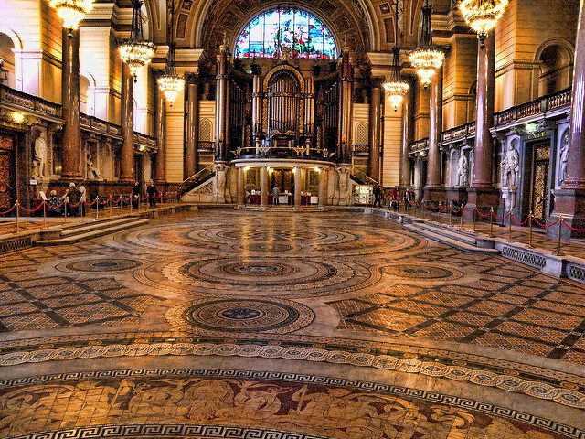
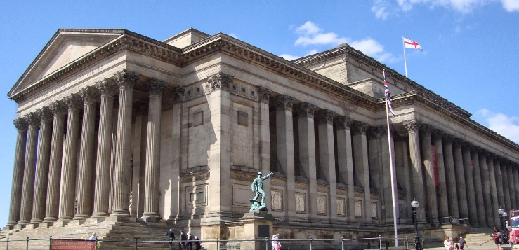

Media
Local media companies will be contacted within the areas that the exhibitions take place so that we are able to raise the profile of some of the work that is taking place within our schools. The press office of the Archdiocese will be approached in order to support this.
Date of submission
All pieces of work should be ready for collection by Monday 3rd April, 2017. Each piece of work should be clearly labelled.
If you require any further information please contact me via email p.greenall@rcaol.co.uk
Many thanks,
Paul Greenall
Partnership Director

